#include <Wire.h>

const int I2C_ADDRESS = 0x50;

int systolic = 0;
int diastolic = 0;
int hr = 0;

void setup() {
Serial.begin(115200);

Wire.begin();

delay(1000);

Serial.println("Arduino pret.");
Serial.println("En attente d'une mesure...");
}

void loop() {

int measurementCount = getMeasurementCount();

if (measurementCount > 0) {

int addr = (measurementCount - 1) * 4;

if (readLastMeasurement(addr)) {

Serial.println("-------------------------");
Serial.print("SYS : ");
Serial.print(systolic);
Serial.println(" mmHg");

Serial.print("DIA : ");
Serial.print(diastolic);
Serial.println(" mmHg");

Serial.print("FC : ");
Serial.print(hr);
Serial.println(" bpm");

Serial.println("-------------------------");

delay(3000);
}
}

delay(500);
}

int getMeasurementCount() {

Wire.beginTransmission(I2C_ADDRESS);
Wire.write(0xFF);

if (Wire.endTransmission() != 0) {
Serial.println("Erreur I2C");
return 0;
}

Wire.requestFrom(I2C_ADDRESS, 1);

if (Wire.available()) {
byte count = Wire.read();

Serial.print("Nombre de mesures : ");
Serial.println(count);

return count;
}

return 0;
}

bool readLastMeasurement(int addr) {

Wire.beginTransmission(I2C_ADDRESS);
Wire.write(addr);

if (Wire.endTransmission() != 0) {
Serial.println("Erreur lecture I2C");
return false;
}

Wire.requestFrom(I2C_ADDRESS, 4);

if (Wire.available() != 4) {
Serial.println("Erreur : 4 octets attendus");
return false;
}

hr = Wire.read();
diastolic = Wire.read();

byte data = Wire.read();

systolic = Wire.read();

// La pression systolique est stockée divisée par 2
systolic *= 2;

// Si le bit indique une valeur impaire
if (data == 0x80) {
systolic += 1;
}

return true;
}
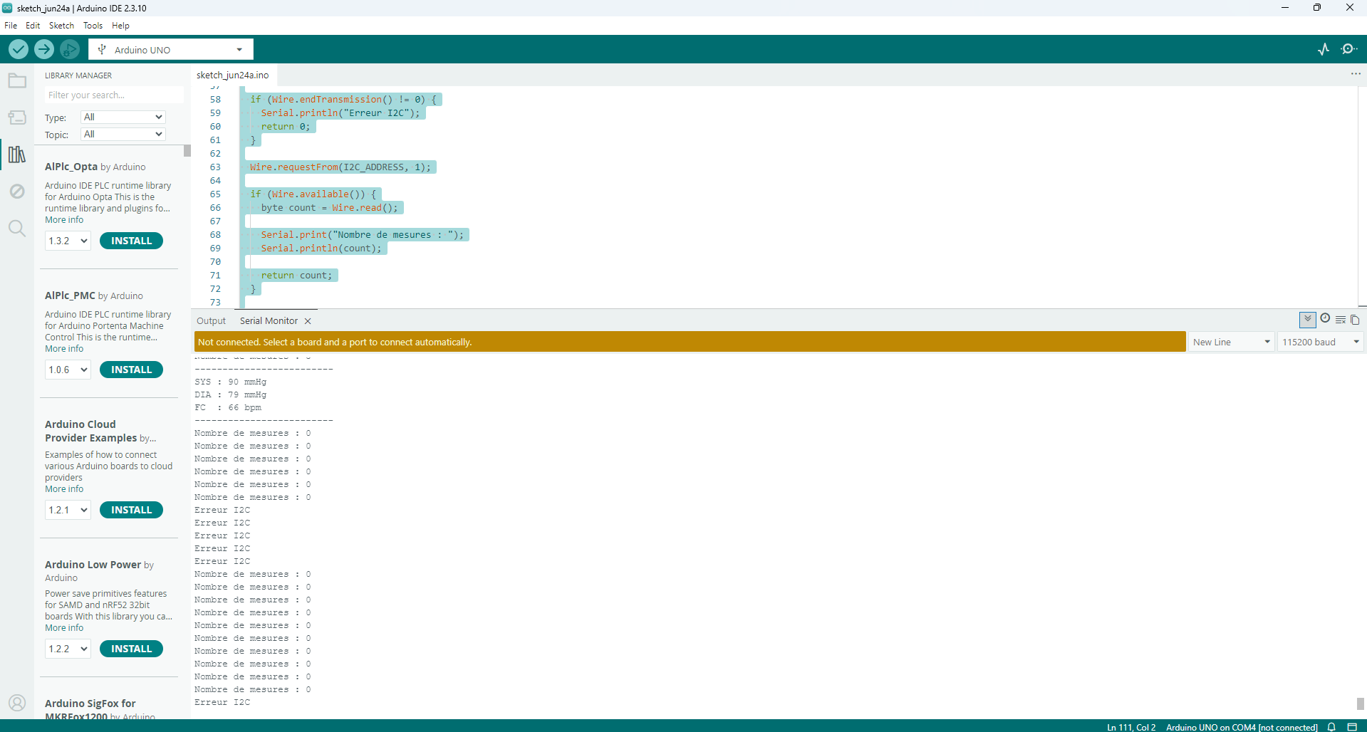

QKF98-BNFWT-Y4HTR-BVTMP-7CFC2
#include <Wire.h>

const int I2C_ADDRESS = 0x50;

int systolic = 0;
int diastolic = 0;
int hr = 0;

void setup() {
Serial.begin(115200);

Wire.begin();

delay(1000);

Serial.println("Arduino pret.");
Serial.println("En attente d'une mesure...");
}

void loop() {

int measurementCount = getMeasurementCount();

if (measurementCount > 0) {

int addr = (measurementCount - 1) * 4;

if (readLastMeasurement(addr)) {

Serial.println("-------------------------");
Serial.print("SYS : ");
Serial.print(systolic);
Serial.println(" mmHg");

Serial.print("DIA : ");
Serial.print(diastolic);
Serial.println(" mmHg");

Serial.print("FC : ");
Serial.print(hr);
Serial.println(" bpm");

Serial.println("-------------------------");

delay(3000);
}
}

delay(500);
}

int getMeasurementCount() {

Wire.beginTransmission(I2C_ADDRESS);
Wire.write(0xFF);

if (Wire.endTransmission() != 0) {
Serial.println("Erreur I2C");
return 0;
}

Wire.requestFrom(I2C_ADDRESS, 1);

if (Wire.available()) {
byte count = Wire.read();

Serial.print("Nombre de mesures : ");
Serial.println(count);

return count;
}

return 0;
}

bool readLastMeasurement(int addr) {

Wire.beginTransmission(I2C_ADDRESS);
Wire.write(addr);

if (Wire.endTransmission() != 0) {
Serial.println("Erreur lecture I2C");
return false;
}

Wire.requestFrom(I2C_ADDRESS, 4);

if (Wire.available() != 4) {
Serial.println("Erreur : 4 octets attendus");
return false;
}

hr = Wire.read();
diastolic = Wire.read();

byte data = Wire.read();

systolic = Wire.read();

// La pression systolique est stockée divisée par 2
systolic *= 2;

// Si le bit indique une valeur impaire
if (data == 0x80) {
systolic += 1;
}

return true;
}

